Lab Assignment 1 (MongoDB)

Q1. Create a database named collegeDB and switch to it.
Command used:
use collegeDB
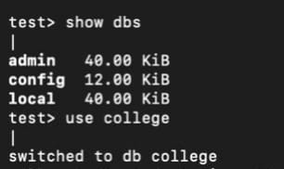

Q2. Create a collection named students in the collegeDB database.
The collection is automatically created when the first document is inserted:
db.students.insertOne({...})
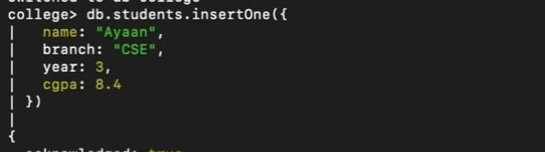
Q3. Insert one document into the students collection with the given fields.
db.students.insertOne({
name: "Ayaan",
branch: "CSE",
year: 3,
cgpa: 8.4
})

Q4. Insert four more documents into the students collection with different values.
db.students.insertMany([
{ name: "Aditi Verma", rollNo: 102, department: "ECE", age: 19 },
{ name: "Kunal Mehta", rollNo: 103, department: "ME", age: 21 },
{ name: "Sneha Patil", rollNo: 104, department: "IT", age: 20 },
{ name: "Arjun Rao", rollNo: 105, department: "CE", age: 22 }
])
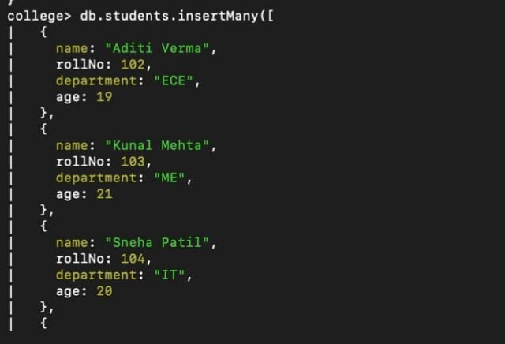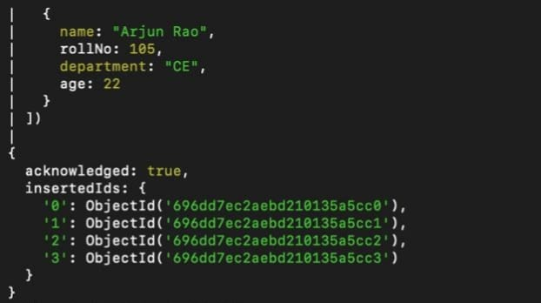

Q5. Display all documents present in the students collection.
db.students.find().pretty()
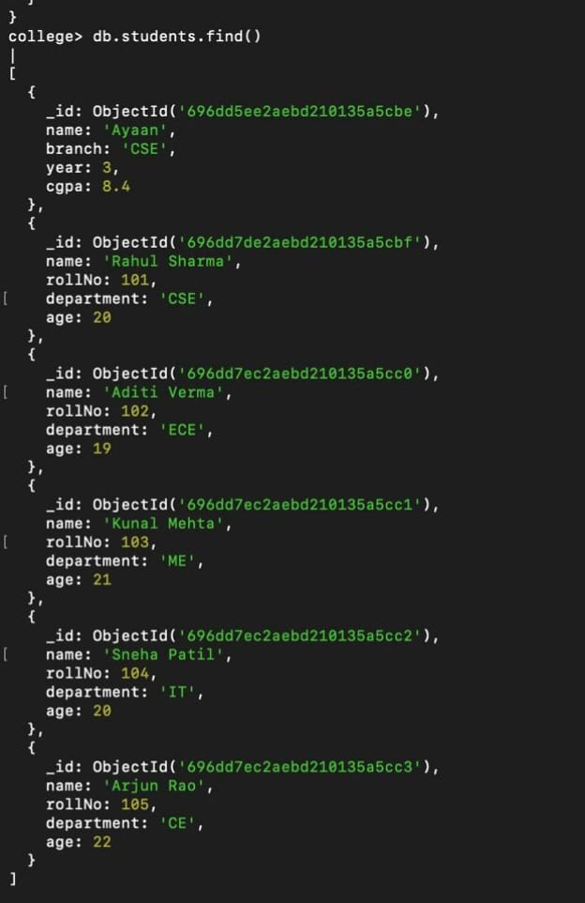

Q6. Display only those students who belong to the CSE department.
db.students.find({ department: "CSE" })
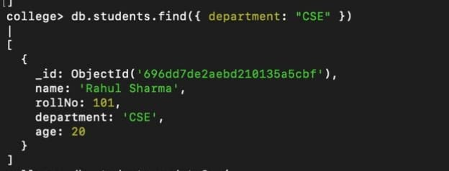

Q7. Update the age of one student (any one) to a new value.
db.students.updateOne(
{ name: "Rahul Sharma" },
{ $set: { age: 21 } }
)
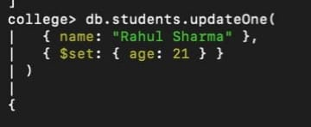
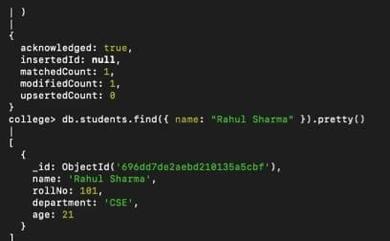

Q8. Delete one document from the students collection using any condition.
db.students.deleteOne({ rollNo: 105 })
